OUTCOME BUDGET
2011-12

MINISTRY OF CULTURE

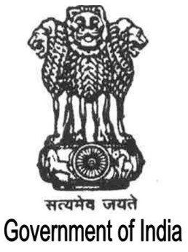
GOVERNMENT OF INDIA
Contents

Page No.

Executive Summary i-ii

Chapter I 1-12

Chapter II 13-112

Chapter III 113-119

Chapter IV-A 120-212

Chapter IV-B 213-319

Chapter V 320-330

Chapter VI 331-346

